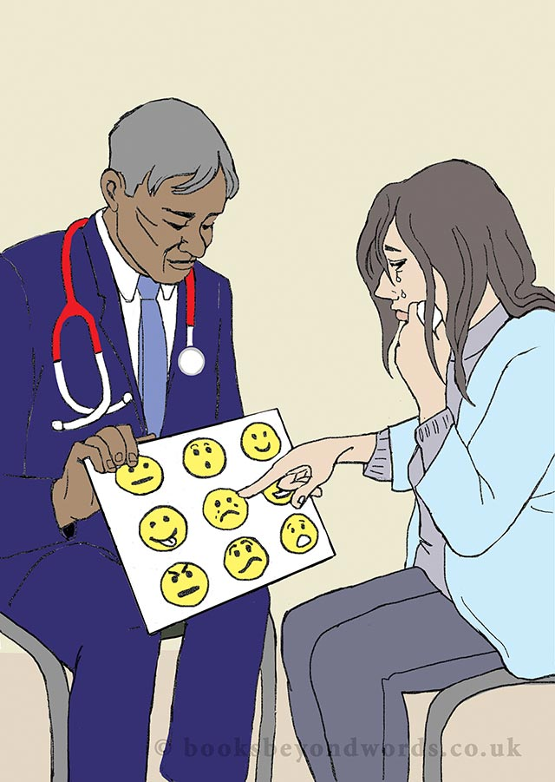  Have you encountered a patient with a learning disability?  Ever wondered what it means to have an autistic spectrum disorder (ASD) or aN ATTENTION DEFICIT HYPERACTIVITY DISORDER (ADHD)?  Attend this FREE ONE DAY SEMINAR on  NEURODEVELOPMENTAL  PSYCHIATRY  - Epilepsy ASD ADHD Genetics  - Research MDT Leadership  will be among topics covered BY EMINENT CONSULTANT SPEAKERS aimed at medical students/junior doctors | 15th june  ────  UNIVERSITY OF LEICESTER  Centre for Medicine  ────  9.30-3pm  ────  FREE LUNCH  ────  Certificates of attendance  ────  All you need to do is let us know you are coming (so we can make sure we have enough food!)  No later than……..
Contact Diane.wheeldon@nottshc.nhs.uk to register

