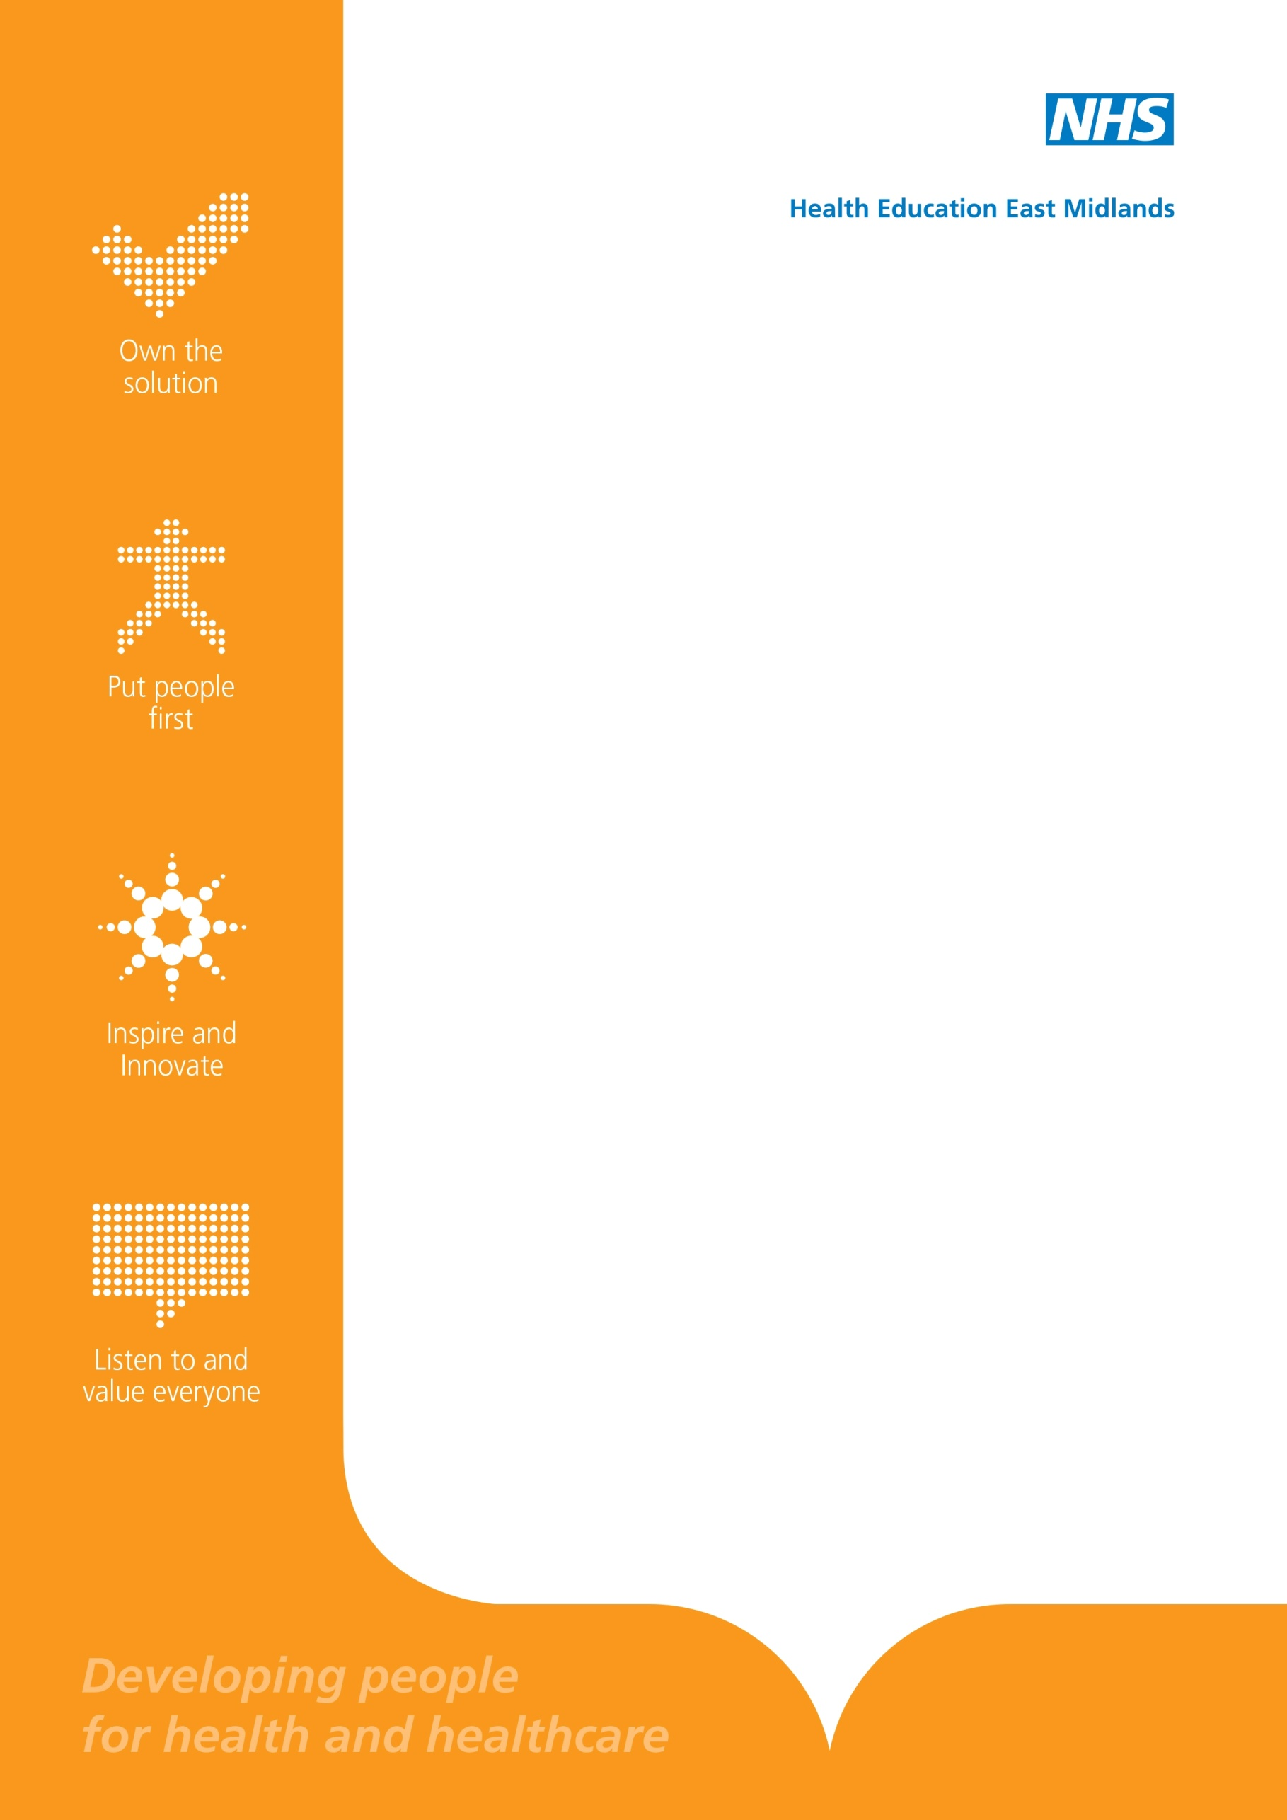
Case Portfolio:
Types of cases referred to SCRG to be listed as a resource for Educators

Serious Concerns Review Group (SCRG)

Foreword

The Serious Concerns Review Group has been in existence since 2012. During this time the members of the group have been able to categorise themes that have led Educators to refer trainees to them for consideration. The largest category has involved falsifying of documentation (20%), with health and criminal activty accounting for another 18% of referrals each.
The SCRG have looked at these cases and thought it would be useful to produce summary documents that describe the kinds of cases with the type of advice given by the SCRG and the action taken by the GMC. These cases are not ‘real’ cases, but based on an amalgamation of a number of different cases. The ‘cases’ are not attributable to any one individual. We hope that these ‘case’ studies will provide information and insight to trainers and trainees to the consequences of some behaviours exhibited by trainees and the sanctions that the GMC have imposed.
In the GMCs “Guide for health professionals on how to report a doctor to the GMC” it is clear that the GMC expect the majority of cases to be resolved at local level by the training programme and it is the experience of the SCRG that robust evidence is required by the GMC for them to acept a referral.
I would like to thank Dr Kevin Hill for compiling the Case Studies and for the SCRG members in taking the time to review and provide invaluable advice to Dr Hill.

Dr B T Langham
Chair of the Serious Concerns Review Group

Contents

Foreword 2
Theme: Fictitious qualifications / portfolio entries 4
Theme- Use of social media 5
Theme- Dishonesty 6
Theme- Health concerns 7
Theme- Performance concerns – release from training 8
Theme- Significant Untoward Incidents – Coroner’s Inquests 9
Theme- Fraud 10
Theme- ARCP Outcome 4 – release from training 11

Theme: Fictitious qualifications / portfolio entries

Background In an application form for specialist training a trainee stated that she had a postgraduate qualification which was subsequently found not to be the case. Another trainee was found to have created fictitious entries in their e-portfolio.

GMC Guidance Good Medical Practice paragraph 65 states ‘You must make sure that your conduct justifies … the public’s trust in the profession. Paragraph 71 also states that ‘you must make sure that any documents you write or sign are not misleading’.

SCRG Comment Whilst the SCRG can recommend to the Postgraduate Dean, as Responsible Officer, referral to the GMC, employers or others can also make a referral which occurred in the above cases. SCRG would normally recommend GMC referral when alerted to significant probity issues.

Outcome GMC sanctions can vary from a formal warning to erasure from the register. GMC warnings remain on a doctor’s registration for five years with details accessible by the public. In the first case the GMC issued a formal warning to the trainee regarding their future conduct. In other cases trainees have been erased from the register for fabricated information in portfolios or CVs.

Theme- Use of social media

Background After a disagreement with their educational supervisor a trainee posted derogatory comments about the supervisor on a social media site. Another trainee posted inappropriate comments regarding senior Trust manager.

GMC Guidance Good Medical Practice paragraph 36 states ‘You must treat colleagues fairly and with respect. Specific guidance is available on the use of social media
http://www.gmc-uk.org/guidance/ethical_guidance/21186.asp

SCRG Comment Guidance is clear that ‘the standards expected of doctors do not change because they are communicating through social media rather than face to face or through other traditional media’. Both instances described therefore bring into question the trainees’ professional standards.
The Group believed that as ‘first offences’, referral to the GMC was not indicated and it would be appropriate for the trainees to produce a reflective portfolio entry on the incident and develop a learning package for their specialty colleagues on the use of social media.

Outcome The required actions have been completed and the individuals concerned have now been removed from regular SCRG review.

Theme- Dishonesty

Background A trainee completed a cremation form stating that they had seen the body in the hospital mortuary when they had not in fact done so and when subsequently challenged again falsely stated that she had done so. The trainee expressed surprise when referred to the GMC for what they perceived as a relatively minor issue. Another trainee was given a police caution following theft of equipment from their previous hospital post. The trainee was remorseful and apologised, notifying the GMC of their caution.

GMC Guidance Good Medical Practice paragraph 65 states ‘You must make sure that your conduct justifies … the public’s trust in the profession. Paragraph 71 also states that ‘you must make sure that any documents you write or sign are not misleading’. You must inform the GMC without delay if ‘anywhere in the world … you have accepted a caution from the police or have been charged with or found guilty of a criminal offence’ (paragraph 75)

SCRG Comment Trainees have a professional duty to inform the GMC (and for GP trainees the Local Area Team under Performers List regulations) of cautions, charges or convictions. Failure to fulfil this responsibility or demonstrate insight or reflection on concerns raised would be considered as significant negative factors when a case is considered by SCRG.

Outcome In the first case, the GMC were concerned that the trainee had not demonstrated sufficient insight into what it considered a serious infringement of Good Medical Practice – The trainee received a six months suspension of their registration. Suspension of GMC registration will normally result in loss of the national training number. In the latter case a formal warning was considered sufficient sanction. GMC warnings remain on a doctor’s registration for five years with details accessible by the public.

Theme- Health concerns

Background The SCRG was made aware of a doctor appointed to specialty training who had a history of psychological health issues. This from time to time resulted in aberrant behaviour. The trainee was supported in their programme and was being monitored by the GMC’s medical advisors and occupational health.

GMC Guidance Good Medical Practice (paragraph 28) places an obligation on doctors that ‘if your judgement or performance could be affected by a condition or its treatment, you must consult a suitably qualified colleague. You must follow their advice about any changes to your practice they consider necessary. You must not rely on your own assessment of the risk to patients’.

SCRG Comment The SCRG’s view is that most trainees with health issues can be supported through training and do not require consideration by SCRG. However, should there be a concern that the trainee is not complying with Good Medical Practice guidance, if it becomes evident that a trainee is not complying with any restrictions on their registration, or they may pose a patient safety issue then referral for consideration of GMC referral would be appropriate.

Outcome The GMC agreed undertakings with the trainee in respect of monitoring their health. Health undertakings / conditions are not in the public domain. These will normally include provision for review by a GMC appointed medical advisor. The trainee continues to be supported through training with occupational health input.

Theme- Performance concerns – release from training

Background A number of trainees are released from training each year because they have failed to progress satisfactorily through their programme. Some trainees lack insight into their difficulties failing to acknowledge the deficiencies in their performance which have led to this decision. The level of underperformance may pose a significant patient safety risk. .

GMC Guidance Good Medical Practice paragraph 22b states ‘You must regularly reflect on your standards of practice and the care you provide’. All medical practitioners have responsibilities to seek advice from the appropriate authorities if a colleague may be putting patients at risk (paragraph 25b)

SCRG Comment SCRG’s primary responsibility is to patient safety. Medical members of SCRG also have a personal professional responsibility to act on perceived patient safety risks. Doctors released from training may undertake locum placements outside of the HEEM area where the performance concerns identified might not be adequately supported. Therefore to ensure that employers are aware, referral to the GMC may be appropriate.

Outcome GMC actions depend on the level of concerns. Sometimes no action is necessary but on other occasions conditions have been imposed on registration or undertakings agreed with the practitioner to limit the scope of practice or ensure appropriate supervision in future posts.

Theme- Significant Untoward Incidents – Coroner’s Inquests

Background A number of trainees referred to SCRG have been involved in SUIs resulting in the death of a patient, where the care provided by the trainee may be subject to criticism. Concerns identified include trainees co-operating with the employer and being adequately prepared for a Coroner’s Inquest where they might be subject to robust questioning and public / media scrutiny.

GMC Guidance Good Medical Practice paragraph 23a states ‘To help keep patients safe you must contribute to confidential enquiries.

SCRG Comment SCRG’s is concerned that trainees may not recognise the implications and associated stresses of being called as a witness to a Coroner’s inquest. Trainees should make use of available support e.g. employer / medical defence organisation and prepare appropriately.

Outcome Whilst it is unusual for any significant action to be taken by the Coroner, it is possible for the Coroner to initiate a GMC referral..

Theme- Fraud

Background A trainee retained a prescription pad from their previous place of work and whilst working in Accident and Emergency prescribed a hypnotic medication to a work colleague who was suffering from insomnia. The prescription was identified by the NHS prescribing authority as irregular. Another trainee submitted a travel expenses claim for a period of study leave which he did not actually attend.

GMC Guidance Good Medical Practice paragraph 77 states ‘You be honest in financial and commercial dealings with employers, insurers and other organisations or individuals’.

SCRG Comment Whilst fraudulent activity may not necessarily be referred to SCRG, NHS Counter Fraud or employers may directly refer a doctor to the GMC where fraudulent activity has been identified. Employers have a responsibility to alert the LETB when a trainee is being investigated for a disciplinary or conduct matter.

Outcome The GMC take probity matters seriously as these undermine the public’s trust in the profession. Whilst in minor cases a warning may be a issued, other GMC sanctions such as a period of suspension from the register is not uncommon. Suspensions from the register may result in the loss of a trainee’s National Training Number.

Theme- ARCP Outcome 4 – release from training

Background A number of trainees are released from training each year having failed to make satisfactory progress towards completion of training. When an appeal panel upholds an ARCP Outcome 4, it sometimes becomes evident that there are significant patient safety issues, into which the trainee may lack insight. The panel may recommend that the Responsible Officer or SCRG is alerted for possible GMC referral.

GMC Guidance Good Medical Practice paragraph 25c states ‘If you have concerns that a colleague may not be fit for practice and may be putting patients at risk ... you must report this in line with our guidance and your workplace policy and make a record of the steps you have taken’.

SCRG Comment No all Outcome 4 decisions need SCRG referral and once released from training, a trainee may take up a non-training post at a level at which they were previously deemed competent. However, if there are significant patient safety concerns it is important to recognise that following release from training, a doctor may take up a Trust grade post in another area and their new supervisor may be unaware of the issues. In these circumstances involvement of the GMC is necessary

Outcome In a number of cases referred the GMC has agreed that the patient safety concerns identified pose a potential risk and have placed Conditions on a doctor’s registration, for example, restricting the type of operations they can undertake, the posts they may work in or stipulating the level of supervision they must have.

