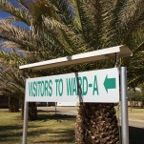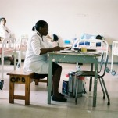

Out of Programme Experience – Exciting! Challenging! Rewarding!

Health Education East Midland is pleased to offer, through Africa Health Placements www.ahp.org.za one year out of programme clinical posts, based in rural community hospitals in South Africa, starting in August 2020. Africa Health Placements is an organisation with a mission: to support and enhance healthcare systems in Africa, by finding, placing and retaining the right people for the job.

The posts will be offered to those applicants who successfully complete their CT2 year and prior to entering CT3. The successful applicants will return to complete their Higher Specialist Training. The aim of these posts is to enable trainees to extend their training and enhance their skills and competencies in resource poor environments.

The jobs will be available within the context of Time Out of Programme (OOPE) as described in the Health Education East Midlands OOPE guidance.

Full support is given to all trainees prior to departure, during the 12 months away and upon your return back to the UK.

For mor information or if you have any question please contact Dr Prit Chahal at prit.chahal@hee.nhs.uk or Dr Al-Jayyousi at Reem.Al-Jayyousi@hee.nhs.uk

Africa Health Placements are also very willing to answer any questions you may have – Esther Dlamini estherd@ahp.org.za

The application will be available on the website at the time of induction around August 2018.

