Welcome to

Health Education England working across the

East Midlands
Training Scheme

Specialty Programme Welcome Pack 2019

Introduction
Welcome to the East Midlands

Health Education East Midlands (HEEM) is the Local Education and Training Board that covers Derbyshire, Leicestershire, Lincolnshire, Northamptonshire and Nottinghamshire. All of our Training Programmes offer you an exceptionally varied training experience.

The deanery website details more information regarding our area:

East Midlands Deanery

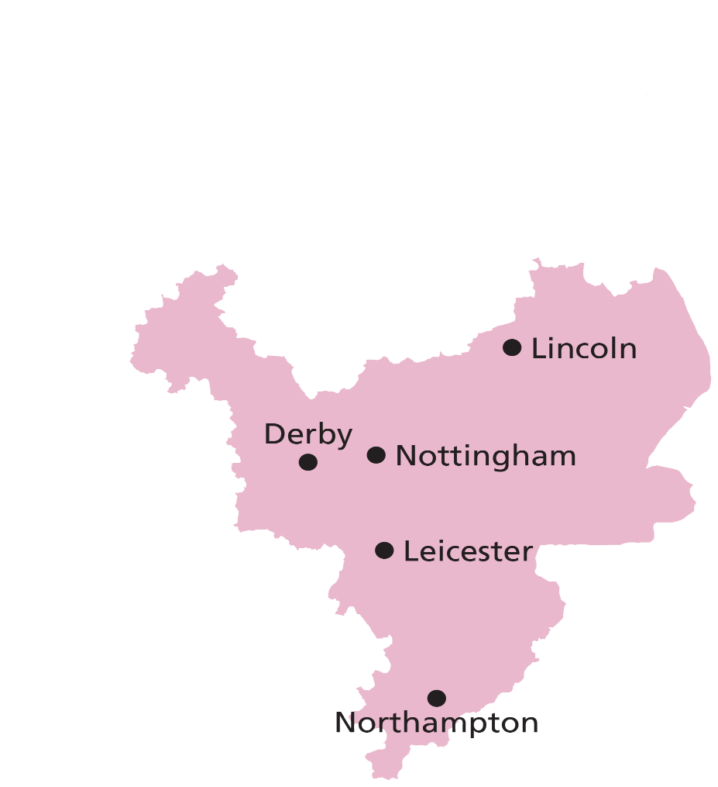

Structure of Health Education England working across the East Midlands
Each training specialty belongs to a Postgraduate School and each Postgraduate School has a Head of School who reports directly to the Postgraduate Dean.
General Medical Council
Royal Colleges
Postgraduate Dean
Heads of Postgraduate Schools
Specialty Training Committee Chairs
Training Programme Directors
Local Education Providers (LEPs) i.e. NHS Trusts

Information on each Postgraduate Specialty School can be found on the East Midlands website: East Midlands Deanery

In addition, there is a Programme team working within the East Midlands local office. Please contact the relevant inbox as per the information below.

PROGRAMME MANAGEMENT TEAM | CONTACT DETAILS
Programme Management Generic Inbox  - Placements  - Database Information  - Registration Documents  - Less Than Full Time applications  - Less Than Full Time queries | Secondary Care: SpecialtyProgrammes.EM@hee.nhs.uk  Primary Care: GPProgrammes.EM@hee.nhs.uk
Out of Programme Training  - Out of Programme applications  - Out of Programme queries | OOP.EM@hee.nhs.uk
Assessments Team  - Organising ARCPs  - Updating ePortfolio (where applicable) | Secondary Care: Assessments.EM@hee.nhs.uk  Primary Care: GPAssessments.EM@hee.nhs.uk
Revalidation  - Queries about Revalidation and Designated Body  - Form R part B | Revaildation.EM@hee.nhs.uk
Study Leave  - Applying for Study Leave  - Using the Intrepid/Accent online system | CSL.EM@hee.nhs.uk

Reference guide for Postgraduate Specialty training in the UK
(The Gold Guide - 7th Edition – 2018)

The Gold Guide is the reference guide for specialty training in the UK and covers all doctors in training (both core and specialty) appointed from August 2007 onwards.

The Gold Guide covers all areas of training including:
- The structure of training
- Becoming a Specialty Registrar, to include Less Than Full Time Training, movement between LETBs/deaneries, taking time out of programme
- Progressing as a Specialty Registrar, to include the Annual Review of Competence Progression (ARCP) process
- Being a Specialty Registrar and an Employee

It is recommended that all trainees familiarize themselves with the contents of the Gold Guide which can be downloaded from the COPMeD website:
The Gold Guide – 7th Edition

Registration with the Royal College
Regardless of your training specialty, it is imperative that you register as a trainee with the appropriate Royal College prior to commencing your post. Failure to enroll with the Royal College could result in your training not being recognized which could impact on your future eligibility for specialty training and the award of a CCT if you are on a run through programme. Please see Appendix 1 for contact details in each College.

Form R
Prior to starting your Training Programme, you are required to complete a Form R (Part A and Part B). This form needs to be completed as soon as possible as your National Training Number / Deanery Reference Number (NTN/DRN) cannot be issued unless we are in receipt of this form.
All doctors, as part of revalidation, are required to record and reflect on significant events in their work with the focus on what they have learnt as a result of the event/s. You will be required to provide details of any significant events you have either been directly or indirectly involved into Health Education England, using the ‘Form R’, before you commence your training post. You will complete a Form R Part B every year as a requirement for your ARCP and revalidation. These are standard national forms.
You will also be required to provide details of any investigations or complaints you have been involved with. Health Education England will again require this information before you commence your training post and this forms part of the information provided on the “Form R”.
Form R Part A and B with guidance on how to complete the form and creating Digital ID’s can be found here:
New Starters
We require receipt of your Form R Part A, B, Training Agreement and most recent Appraisal / ARCP no later than 1 month after your Programme start date. Please send these to the Programme Management Team (specialtyprogrammes.em@hee.nhs.uk) and the Revalidation Team (revalidation.em@hee.nhs.uk) and the teams will process your forms and release your training number. If you have any issues or questions regarding Form R, please contact us and someone will be happy to assist you.

Contacts at the trust
The Trust that you are working in will be your employer. This means that your employer will change each time you rotate to a new trust. Your employer / lead employer will issue all Rota and contract information to you prior to starting your placement.

Trainees are expected to familiarize themselves with the policies of their employer and adhere to these accordingly. In addition to the team that you are working with in the hospital, other important contacts for you in the trust will be:

- Medical Staffing – for employment issues
- Postgraduate Clinical Tutor – for approval of study leave
- Educational Supervisor – for guidance on your educational progress
- Postgraduate Centre Manager - for issues relating to postgraduate medical education such as hospital teaching programmes

Transfer of information between trusts
At the time of rotation from one placement to another, information on trainees, including employment information, will be passed from the old employer to the new.

Removal and Travel Expenses – Local Guidance
Health Education England working across the East Midlands has produced an interim policy on claiming relocation and travel expenses. This policy can be found here:

Relocation and Travel Expenses Policy

Less Than Full Time training
You have been offered a full time training post; if you wish to train Less Than Full-Time (LTFT) please refer to the guidance on the Health Education England working across the East Midlands website: Less Than Full Time Training

This site gives further details about LTFT training with Health Education England, including information about eligibility and the application process - please note that you should apply to HEE with no less than 3 months’ notice of their proposed LTFT start date. Applications will be considered against the national eligibility criteria for LTFT training. Health Education England aims to offer support to all trainees who meet the national eligibility criteria to train LTFT; however, trainees must be appointed to a Full Time Programme to be able to progress their LTFT training application.

Out of Programme
Out of Programme (OOP) relates to trainees that wish to participate in an experience that is out of their planned programme of training. There are a number of circumstances that trainees may wish to spend time out of programme; to gain training or clinical experience, to undertake research or to take a career break.

Time out of programme will not normally be agreed until a trainee has been in a training programme for at least a year and will not normally be allowed in the final year of training other than in exceptional circumstances.

Before applying for OOP, trainees must discuss their plans with their Educational Supervisor and/or Training Programme Director. This discussion will determine the suitability of the out of programme experience and ensures the proposed post will meet the educational needs of the trainee.

Health Education working across the East Midlands requires OOP Application Forms and supporting documentation to be submitted at least 6 months in advance of the proposed OOP start date; exceptions will only be agreed by the Post Graduate Dean. Trainees must inform their current employer at least 3 months in advance to ensure that the needs of patients are appropriately addressed.

Guidance on how to apply for Out of Programme can be found on the Health Education working across the East Midlands website: Out of Programme

Parental/Sick Leave
During your training you may need to take a period of statutory leave (such as parental or sick leave). If this does occur, please can you make sure to keep the following people and organisations informed (with exact dates where possible):

- Your employing organisation or trust – This is part of your obligation as an employee to ensure you are paid correctly and cover can be arranged.

- Your Training Programme Director or equivalent (for GP please contact your local programme office, i.e. Nottingham or LNR) – These consultants/administrators are responsible for arranging your placements and so will need to take your leave into account.

- The HEE Programme Management Team (see page 3 for contact details) – This team manages Trainee Information System (TIS) which is the primary database for recording your training time. Keeping TIS up to date is imperative for ensuring the trust ESR system is accurate for pay and your CCT date is calculated correctly.

If you ensure all three of the above are kept informed of any changes to your programme or placements it will greatly minimise data issues throughout your training.

Revalidation
Revalidation came into effect for doctors in training at the end of 2012. The Responsible Officer for all Trainee Doctors is the Postgraduate Medical Dean. Revalidation will be undertaken through an enhanced ARCP process.

For further information relating to revalidation please refer to Health Education England working across the East Midlands website: Revalidation

Professional Support
The Professional Support and Wellbeing (PSW) aims to support all doctors in training whose performance may have been affected by circumstances that have arisen preventing progression throughout the training process, whether these circumstances are personal, training or work related.

The PSW provides a consistent, single point of access to expert advice, guidance and information regarding concerns to all parties involved in the management of medical trainees.

A referral to the PSW is a non-punitive measure and remains confidential whilst enabling trainee's within the East Midlands to access fully funded external support measures from providers specializing in working with doctors.

More information on Professional Support can be found on the Professional Support and Wellbeing section of the Health Education working across the East Midlands website: Professional Support and Wellbeing

Escalating Concerns
Postgraduate Medical Trainees are encouraged to raise concerns when appropriate regarding their training programme via a number of mechanisms such as the GMC Survey, Job Evaluation Survey Tool (JEST), Reviews/Visits to Local Education Providers (LEPs), Annual Review of Competency Progression (ARCP), Appraisals, and Incident Reporting etc.

When issues arise that are not appropriate or out of sequence with these processes, trainees may raise concerns by using the following pathways as appropriate to their concern. Concerns may cover any issue including patient safety and quality of education and training. Trainees should invoke pathways appropriately and in order of priority.

Resignation from training programme
You are required to notify Health Education England working across the East Midlands, your employing trust and your Training Programme Director should you decide to resign from the training programme. Please contact your Employing Trust regarding Notice Lengths.

And finally…
If there is any other information that you would like to receive that has not been provided as part of this welcome pack, please do not hesitate to contact the Programme Management Team via the address relevant to you.

Specialtyprogrammes.em@hee.nhs.uk or GPProgrammes.em@hee.nhs.uk

May we take this opportunity to congratulate you on your appointment and wish you success in the completion of your training Programme in the East Midlands.
Appendix 1 – Royal College Contact Details

Royal College of Anaesthetists Churchill House  35 Red Lion Square London  WC1R 4SG  Tel: 0207 092 1500  Email: info@rcoa.ac.uk  Website: www.rcoa.ac.uk | Royal College of Ophthalmologists 18 Stephenson Way  Kings Cross  London NW1 4QW  Tel: 020 3770 5353  Email: membership@rcophth.ac.uk  Website: www.rcophth.ac.uk
Royal College of Psychiatrists  21 Prescot Street  Whitechapel  London  E1 8BB  Tel: 020 7235 2351  Fax: 0203 701 2761  Email: membership@rcpsych.ac.uk  Website: www.rcpsych.ac.uk | Faculty of Dental Surgery  (Royal College of Surgeons)  35-43 Lincoln’s Inn Fields  London  WC2A 3PE  Tel: 020 7869 6700  Email: membership@rcseng.ac.uk  Website: www.rcseng.ac.uk
Royal College of Paediatrics & Child Health  5-11 Theobalds Road  London WC1X 8SH  Tel: 020 7092 6000  Email: enquiries@rcpch.ac.uk  Website: www.rcpch.ac.uk | Faculty of Public Health Medicine  4 St Andrew’s Place  Regents Park London  NW1 4LB  Tel: 0207 935 0243  Email: membership@fph.org.uk  Website: www.fph.org.uk
Royal College of Obstetricians & Gynaecologists  27 Sussex Place  Marylebone London  NW1 4RG  Tel: 020 7772 6200  Fax: 020 7723 0575  Email: membership@rcog.org.uk  Website: www.rcog.org.uk | Royal College of Pathologists 4th Floor  21 Prescot Street  London  E1 8BB  Tel: 020 7451 6700  Email: info@rcpath.org  Website: www.rcpath.org

Royal College of Radiologists  63 Lincoln's Inn Fields  London  WC2A 3JW  Tel: 020 7405 1282  Email: enquiries@rcr.ac.uk  Website: www.rcr.ac.uk | Faculty of Occupational Medicine  2 Lovibond London  SE10 9FY  Tel: 020 7242 8698  Fax: 020 3116 6900  Email: FOM@fom.ac.uk  Website: www.facoccmed.ac.uk
Royal College of Physicians  11 St Andrew’s Place  Regents Park  London  NW1 4LE  Tel: 020 3075 1649  Website: http://www.jrcptb.org.uk | Royal College of Surgeons  35-43 Lincoln’s Inn Fields London  WC2 3PN  Tel: 020 7405 3474  Website: www.jchst.org
Royal College of Emergency Medicine  7-9 Breams Buildings  London  EC4A 1DT  Tel: 020 7404 1999  Website: http://www.rcem.ac.uk/ | Faculty of Intensive Care Medicine  Churchill House  35 Red Lion Square  London WC1R 4SG  Tel: 020 7092 1688  Email: contact@ficm.ac.uk  Website: http://www.ficm.ac.uk/
Faculty of Community Sexual Reproductive Health  2nd Floor  27 Sussex Place London  NW1 4RG  Tel: 020 7724 5534  Website: https://www.fsrh.org/home/ | Royal College of General Practitioners  30 Euston Square  London  NW1 2FB  Tel: 020 3188 7400  Website: http://www.rcgp.org.uk/

